AWS Console Manual
This manual tries to summarize the services used by Ragnaorc and how to fix the cache-hit issue.

Log in to AWS console and you will be directed to this page
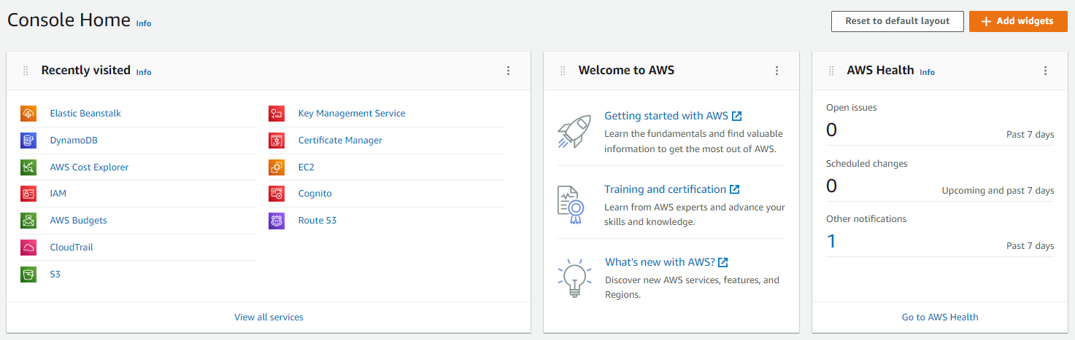

Click on Elastic Beanstalk to view the application environment.
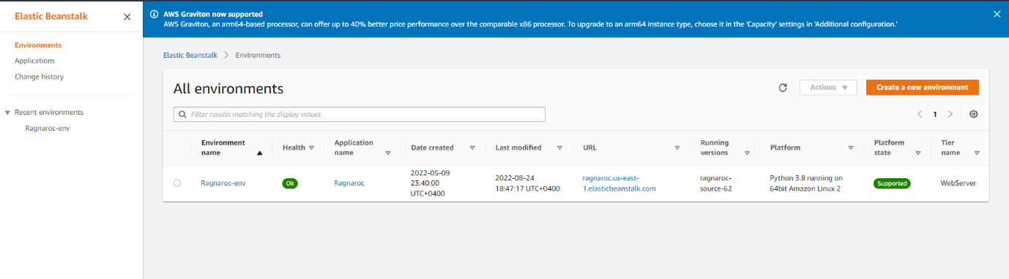
Click on “Ragnaroc-env” to view more details (Such as health, logs, etc.)
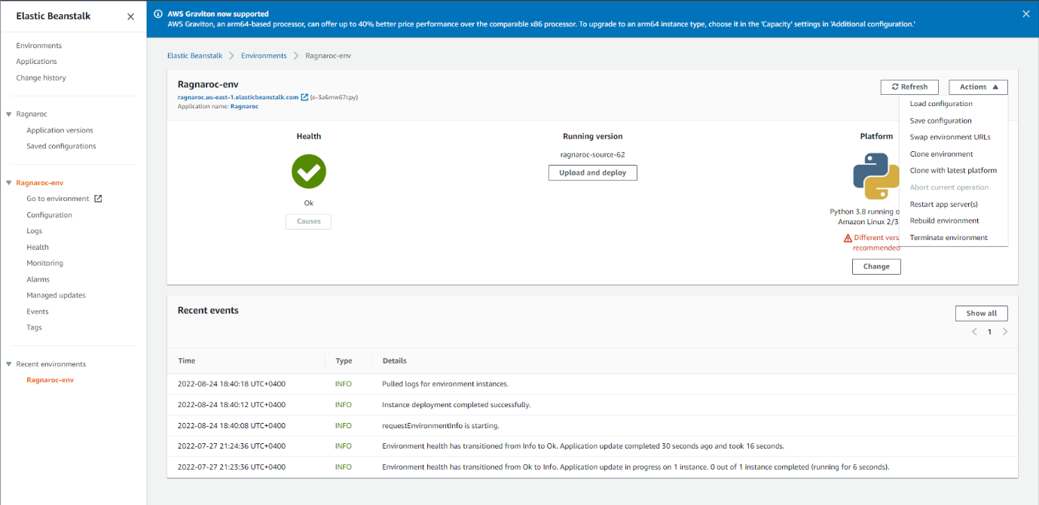

If any changes have been made to the application, please make it into a zip file (template in GitHub) and click “upload and deploy”.
To fix the issue of cache-miss (due to the cron job)
- Click “Actions”
- Click “Restart app-server”

DynamoDB
On the AWS Console page, click on DynamoDB to be redirected to the Dashboard
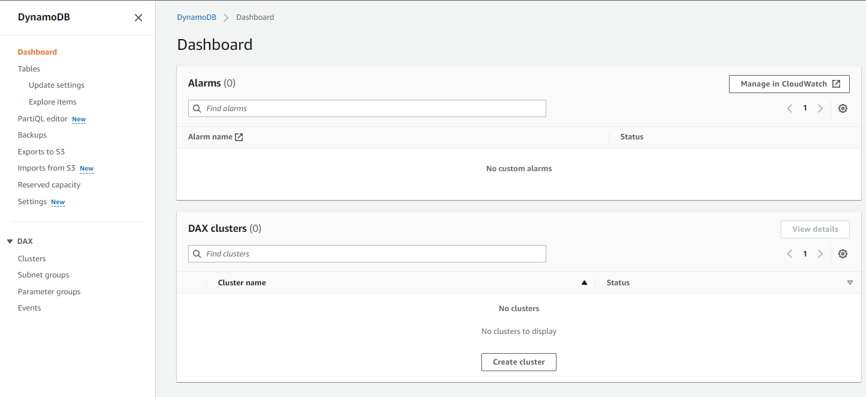
Click on “Tables” to view the existing tables.
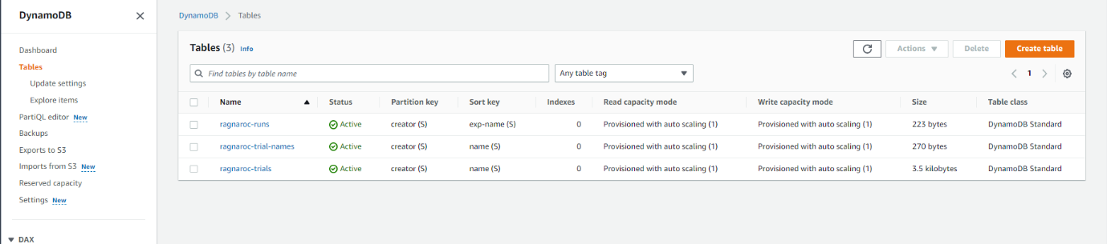
- ragnaroc-trials: To store the detailed configuration of each trial
- ragnaroc-trial-names: Just stores the trial names along with the creator for easy access.
- ragnaroc-runs: To keep track of who ran which experiment.
We can make more tables if need be.
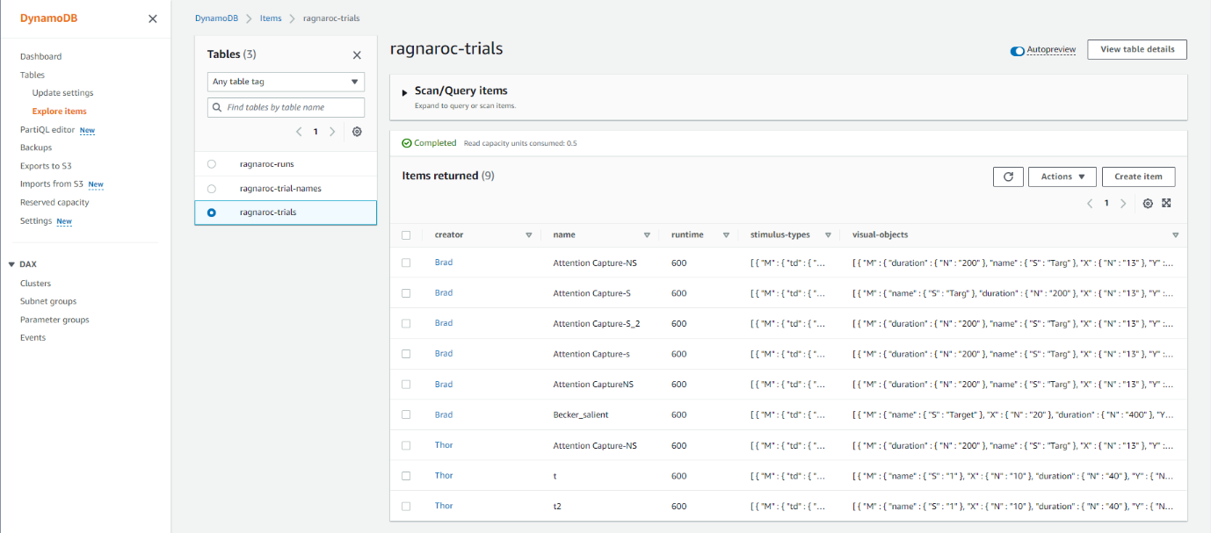

Click on “Explore Items” to view the contents of each table.

